Healthy Soils Sustainable Farms, November 14. 2017
Bruce Whittaker and Jillian Staton
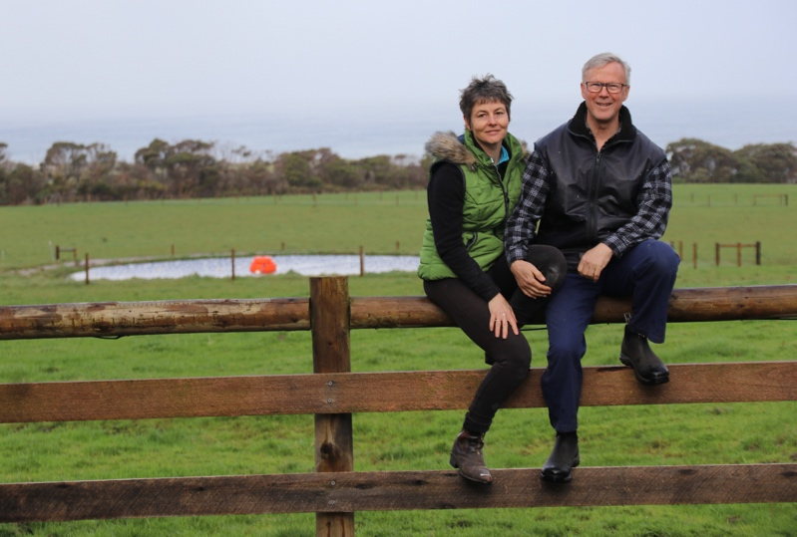
We bought Tarara, which is 100 acres, in 2013. If it had been a house, it would probably have been described as a “renovator’s delight”: it had no fertiliser history, the yards were so run-down as to be dangerous, the boundary fencing was terrible, and only two paddocks had a reliable water supply. Little if no weed control had been carried out, and the pasture was dominated by less productive species such as fog-grass and sweet vernal.
All of this represented a great opportunity for us, however. We had seen on a previous property how effective rotational grazing and weed control had been in improving pasture quality, and were keen to replicate that experience on Tarara. And the amazing view was an extra-special bonus!
Although we had lots of ideas that we were keen to implement immediately (new yards, a laneway and a watering system) we decided to run the farm for at least a year before making any significant changes. This gave us a good feel for the farm across each season. We learnt, for example, which areas were prone to bogging (actually, we are still learning that one), and how much we and the stock value good shelter belts (it gets REALLY windy here!)
The first major change we carried out was to subdivide the paddock which now contains the stock yards. It was a fairly large paddock but more importantly, the spring-fed dam located in the upper shelter belt enabled us to run a trough into the new paddock quite easily and cheaply (this is where having a light, sandy soil has some advantages). We also created a ten metre wide shelter belt along the new fence line which we hope will reduce the bogginess in the southern corners, and provide some respite from the wind in the not-too-distant future.
While this subdivision immediately helped our grazing management in the bottom half of the farm, it highlighted the difficulties we were having in the top half due to the lack of reliable water. The top paddock was reliant on “Dodgy Dam”: a surface-fed dam that, despite being cleaned out, can dry out in summer. We were also using it to supply the second paddock, because we did not want to risk damaging the small dam in the established shelter belt that runs north-south below the house. Moving stock into either paddock therefore involved fiddling with a portable electric fence that was especially annoying in wet or windy weather.
On a more positive note, however, we had earmarked the spot where we planned to build the shed, stables and house. We engaged a contractor to create a driveway to the site, and constructed a curved laneway alongside it to move stock up to the top paddock. We also decided to turn the awkward area in the south-west corner into six small horse paddocks. (Note from Bruce: we now have more horse paddocks than cattle paddock. Hmm.)
Around that time, we got involved in the Healthy Soils, Sustainable Farms program. We had soil tests done in each paddock and the agronomist, Lisa Warn, came out to look at our pastures and talk to us about our stock management. We were surprised to discover that the overall soil fertility was actually quite high, with P and S levels at, or close to target levels and only needing maintenance applications (which we have carried out in April each year), and very high K levels. Despite this, the species composition was poor (due to light grazing in the past), and bracken was a problem in some paddocks.
Lisa suggested that some pastures may have needed renovating. Because of our past experience, however, we were confident that once we got our water infrastructure sorted, we would be able to significantly improve the quality, and the quantity of our pasture through a strict rotational grazing regime, regular fertiliser applications and weed control.
Bruce had already started to look into different strategies for moving water around the property. His preference was to pump water from the spring-fed dam to a tank at the top of the property, and gravity feed to a series of troughs spread across the top half of the farm. This was also a risk management strategy, as the bottom half of the farm is fed from the dam in the shelter belt.
This was excellent in theory but did involve pumping water uphill, and we did not have mains power. Although we had been toying with the idea of going off-grid for the house construction, we had had a bad experience with solar at our other farm and at that stage, were not confident that it could meet our needs.
Bruce considered a number of options for pumping water, including wind (too expensive) and an air compressor (too fiddly), and in the end, decided on a Mono solar pump. We bought the pump from Korrumburra Pumps for around $8000, and had it installed, together with a 50,000l header tank, piping from the dam to the tank and then from the tank to a trough in each paddock in the top half of the farm. In the horse paddocks, we placed troughs in fencelines to feed two paddocks, and did the same in the dam paddock, effectively creating a holding paddock in the laneway.
The day the pump started sending water around the farm was pretty exciting. But our excitement was short-lived: after just a couple of weeks, a pipe came loose, fell into the dam and the pump burnt itself out. We were assured this was very unusual, and after having it repaired it has worked perfectly well ever since.
As we had hoped, the watering system enabled us to rotationally graze the paddocks far more effectively. Depending on the time of year, we aim to graze each paddock for between one and two weeks. Admittedly, we have had a wonderful start to spring, but we have already seen a marked difference in the quality and quantity of our pasture, with a large amount of clover, and an increasing amount of ryegrass. The bracken has almost gone, and cape weed was not nearly as much of a problem as in previous years.
The watering system has been complemented by new stockyards which have a roof and are a pleasure to work in on both hot and wet days. Combined with the laneway, one person can move and process the stock quite easily although we prefer to do it as a pair. Having a large shed has been fantastic, as has finishing stage one of our new home which is powered by an 10 kw solar system that has so far proven to be very efficient.
Other improvements we have made include fencing off and revegetating all of our dams, and creating and/or extending several shelter belts. We applied fertiiser as per Lisa’s recommendations in 2016 and 2017, and keep a close eye on weeds (predominantly cape weed, bracken and thistles). Now that we have our infrastructure sorted, we are in a position to build our stock numbers through purchase and breeding.

